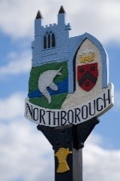 | Northborough  Parish Meeting

To all residents of Northborough Parish

You are invited to attend the Annual Parish Meeting
hosted by Northborough Parish Council
on Saturday, 20th May 2023 commencing at 10.00am
at the Village Hall, Cromwell Close, Northborough

Refreshments will be served

The meeting will include:

Report by Cllr Peter Hiller, Peterborough City Councillor for Glinton and Castor Ward

Report by the Parish Council Chair on recent and forthcoming activity by the Council

Reports by local organisations and groups on their activities and forthcoming plans

The Pack Horse Public House – Update and discussion

‘No Mow May 2024’ - Discussion

Open forum – your opportunity to ask questions or make suggestions to the Council

Summing Up by the Chair

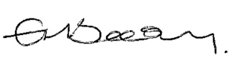

Parish Clerk: Elinor Beesley
clerk@northborough-pc.gov.uk 07713 194173
On behalf of Northborough Parish Council

The holding of a public meeting between 1st March and 1st June each year is a legal requirement
for all parishes in England and in Northborough is hosted by the Parish Council.

